***Chemistry***

**9: Gases**

**9.2: Relating Pressure, Volume, Amount, and Temperature: The Ideal Gas Law**

19. Explain how the volume of the bubbles exhausted by a scuba diver (Figure 9.16) change as they rise to the surface, assuming that they remain intact.

Solution

As the bubbles rise, the pressure decreases, so their volume increases as suggested by Boyle’s law.

21. An alternate way to state Avogadro’s law is “All other things being equal, the number of molecules in a gas is directly proportional to the volume of the gas.”

(a) What is the meaning of the term “directly proportional?”

(b) What are the “other things” that must be equal?

Solution

(a) The number of particles in the gas increases as the volume increases. This relationship may be written as *n* = constant × *V*. It is a direct relationship. (b) The temperature and pressure must be kept constant.

23. How would the graph in Figure 9.13 change if the number of moles of gas in the sample used to determine the curve were doubled?

Solution

The curve would be farther to the right and higher up, but the same basic shape.

25. Determine the volume of 1 mol of CH4 gas at 150 K and 1 atm, using Figure 9.12.

Solution

The figure shows the change of 1 mol of CH4 gas as a function of temperature. The graph shows that the volume is about 16.3 to 16.5 L.

27. A spray can is used until it is empty except for the propellant gas, which has a pressure of 1344 torr at 23 °C. If the can is thrown into a fire (T = 475 °C), what will be the pressure in the hot can?

Solution

The first thing to recognize about this problem is that the volume and moles of gas remain constant. Thus, we can use the combined gas law equation in the form:





29. A 2.50‑L volume of hydrogen measured at –196 °C is warmed to 100 °C. Calculate the volume of the gas at the higher temperature, assuming no change in pressure.

Solution

Apply Charles’s law to compute the volume of gas at the higher temperature:

*V*1 = 2.50 L

*T*1 = –193 °C = 77.15 K

*V*2= ?

*T*2 = 100 °C = 373.15 K





31. A weather balloon contains 8.80 moles of helium at a pressure of 0.992 atm and a temperature of 25° C at ground level. What is the volume of the balloon under these conditions?

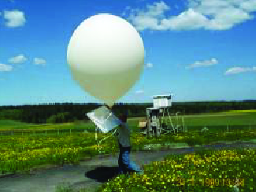

Solution

*PV* = *nRT*



33. How many moles of gaseous boron trifluoride, BF3, are contained in a 4.3410-L bulb at 788.0 K if the pressure is 1.220 atm? How many grams of BF3?

Solution





35. How many grams of gas are present in each of the following cases?

(a) 0.100 L of CO2 at 307 torr and 26 °C

(b) 8.75 L of C2H4, at 378.3 kPa and 483 K

(c) 221 mL of Ar at 0.23 torr and –54 °C

Solution

In each of these problems, we are given a volume, pressure, and temperature. We can obtain moles from this information using the molar mass, *m* = *nM*, where *M* is the molar mass:



or we can combine these equations to obtain:



(a)

;

(b)

;

(c)



37. A cylinder of medical oxygen has a volume of 35.4 L, and contains O2 at a pressure of 151 atm and a temperature of 25 °C. What volume of O2 does this correspond to at normal body conditions, that is, 1 atm and 37 °C?

Solution



39. A 20.0-L cylinder containing 11.34 kg of butane, C4H10, was opened to the atmosphere. Calculate the mass of the gas remaining in the cylinder if it were opened and the gas escaped until the pressure in the cylinder was equal to the atmospheric pressure, 0.983 atm, and a temperature of 27 °C.

Solution

Calculate the amount of butane in 20.0 L at 0.983 atm and 27 °C. The original amount in the container does not matter.



Mass of butane = 0.798 mol × 58.1234 g/mol = 46.4 g

41. For a given amount of gas showing ideal behavior, draw labeled graphs of:

(a) the variation of *P* with *V*

(b) the variation of *V* with *T*

(c) the variation of *P* with *T*

(d) the variation of  with *V*

Solution

For a gas exhibiting ideal behavior:

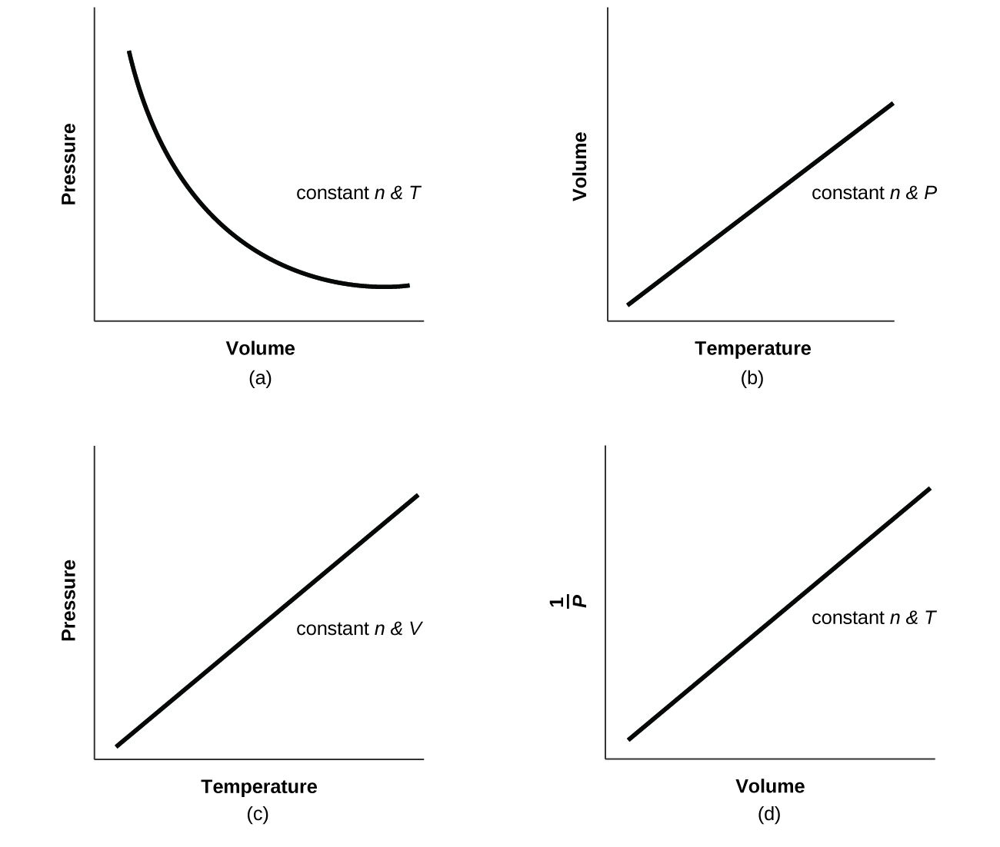

43. The effect of chlorofluorocarbons (such as CCl2F2) on the depletion of the ozone layer is well known. The use of substitutes, such as CH3CH2F(*g*), for the chlorofluorocarbons, has largely corrected the problem. Calculate the volume occupied by 10.0 g of each of these compounds at STP:

(a) CCl2F2(*g*)

(b) CH3CH2F(*g*)

Solution

(a) Determine the molar mass of CCl2F2 then calculate the moles of CCl2F2(*g*) present. Use the ideal gas law *PV = nRT* to calculate the volume of CCl2F2(*g*):



*PV = nRT*, where *n* = # mol CCl2F2

;

(b) 

*PV = nRT*, with n = # mol CH3CH2F

1 atm ×*V* = 0.208 mol × 0.0821 L atm/mol K × 273 K = 4.66 L CH3CH2F

45. A balloon that is 100.21 L at 21 °C and 0.981 atm is released and just barely clears the top of Mount Crumpet in British Columbia.If the final volume of the balloon is 144.53 L at a temperature of 5.24 °C, what is the pressure experienced by the balloon as it clears Mount Crumpet?

Solution

Identify the variables in the problem and determine that the combined gas law  is the necessary equation to use to solve the problem. Then solve for P2:



47. If the volume of a fixed amount of a gas is tripled at constant temperature, what happens to the pressure?

Solution

The pressure decreases by a factor of 3.

This resource file is copyright 2015, Rice University. All Rights Reserved.